Lab: Infrared-Receiver

Introduction
An infrared-receiver (as shown below) is a type of component which can receive infrared signals and can independently complete infrared ray reception and output compatible with TTL level signals. It has similar size with normal plastic package transistors and is appropriate for all kinds of infrared ray remote control and infrared ray data transmission.
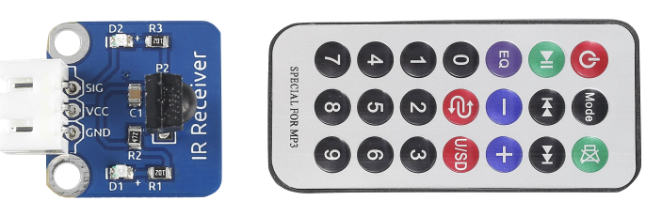

Principle
Control a certain key (for example, Power key) via a remote controller by
programming. When you press the key, infrared rays will be emitted from the
remote controller and received by the infrared receiver, and the LED on the
SunFounder Uno board will light up. Add an LED to connect with pin 13 of the Uno
board, so you can see remotely whether the Power or another key is pressed down.
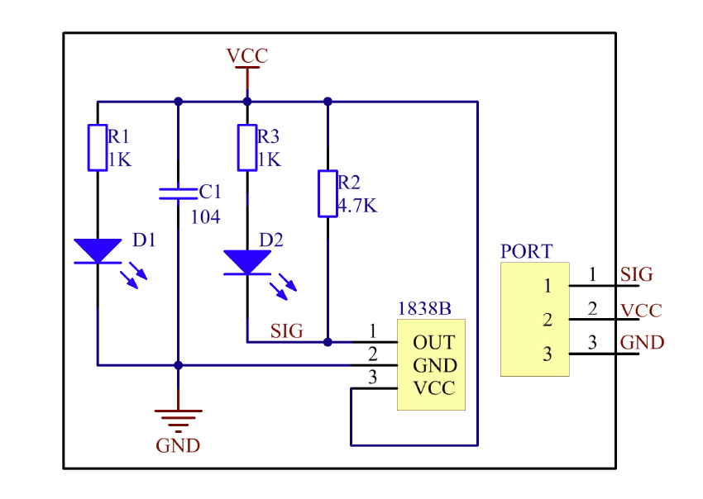

Step 1: Bild the circuit
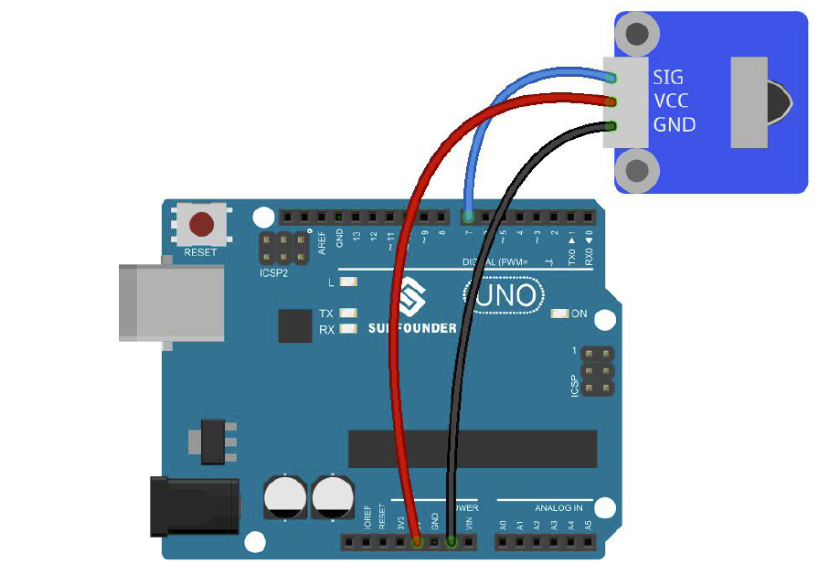

Step 2: Program
Step 3: Compile the program
Step 4: Upload the sketch to Arduino UNO board
Step 5: Turn on Serial Monitor under Tools in Arduino IDE

Now, if you press Power key of a remote controller, the LED attached to pin 13 on the Arduino UNO board will light up. If you press any other key, the LED will go out.

A) Design and implement
  - Hardware implementation with the arduino board and the IR receiver
B) Program

#include <IRremote.h>
const int irReceiverPin =7; //the SIG of receiver module attach to pin7
const int ledPin = 13;//pin 13 built-in led
IRrecv irrecv(irReceiverPin); //Creates a variable of type IRrecv
decode_results results;
void setup()
{
pinMode(ledPin,OUTPUT);//set ledpin as OUTPUT
Serial.begin(9600);//initialize serial
irrecv.enableIRIn(); //enable ir receiver module
}
void loop()
{
if (irrecv.decode(&results)) //if the ir receiver module receiver data
{
Serial.print("irCode: "); //print"irCode: "
Serial.print(results.value, HEX); //print the value in hexdecimal
Serial.print(", bits: "); //print" , bits: "
Serial.println(results.bits); //print the bits
irrecv.resume(); // Receive the next value
}
delay(600); //delay 600ms
if(results.value == 0xFFA25D)//if receiver module receive OxFFA25D
{
digitalWrite(ledPin,HIGH);//turn on the led
}
else
{
digitalWrite(ledPin,LOW);//turn off the led
}
}

C) Test
- Test theHardware implementation with the arduino uno board
- Change the program as below
Press “+” key on the IR remote to display the HEX code on serial monitor, record the HEX code on a piece of paper.
Press “-” key on the IR remote to display the HEX code on serial monitor, record the HEX code on a piece of paper.
Press “>>” key on the IR remote to display the HEX code on serial monitor, record the HEX code on a piece of paper.
Press “<<” key on the IR remote to display the HEX code on serial monitor, record the HEX code on a piece of paper.
Revise the sketch:
Write a dummy function speedUp() to serial print “speeding up now”, write a dummy function slowdown() to serial print “slowing down now”, write a dummy function turnLeft() to serial print “turning left now”, write a dummy function turnRight to serial print “turning right now”.
When “+” key on IR remote is pressed, call speedUp()
When “-“ key on IR remote is pressed, call slowdown()
When “<<” key is pressed, call turnLeft()
When “>>” key is pressed, call turnRight()
Deliverables
Give a demo to TA to show the revised program is working properly.
Discuss how to use additional keys for other robot movements, e.g. go forward, go backward.
Submit the revised code online along with a picture of your circuit.

